**VPC CREATION**

**STEP 1**

**Choose the Service from AWS Console and single click**

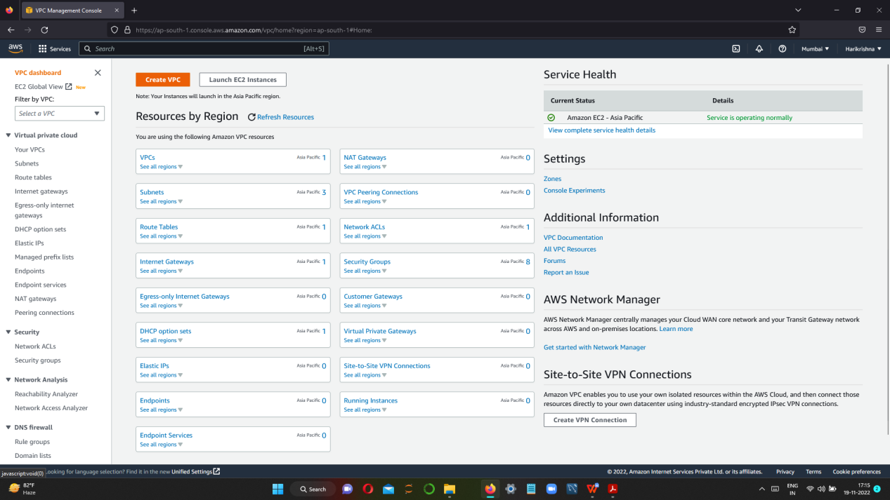

**STEP 2**

**CLICK CREATE VPC**

**ENTER VPC NAME**

**GIVE IPV4 CIDR**

**CLICK CREATE**

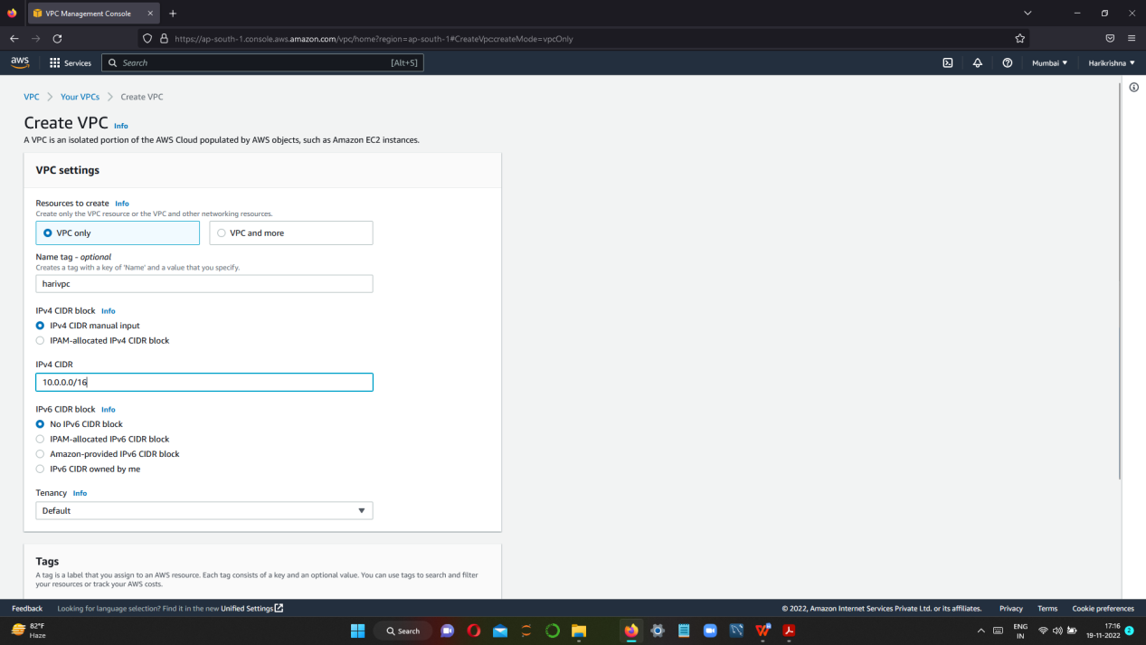

**SUCCESSFULLY VPC CREATED**

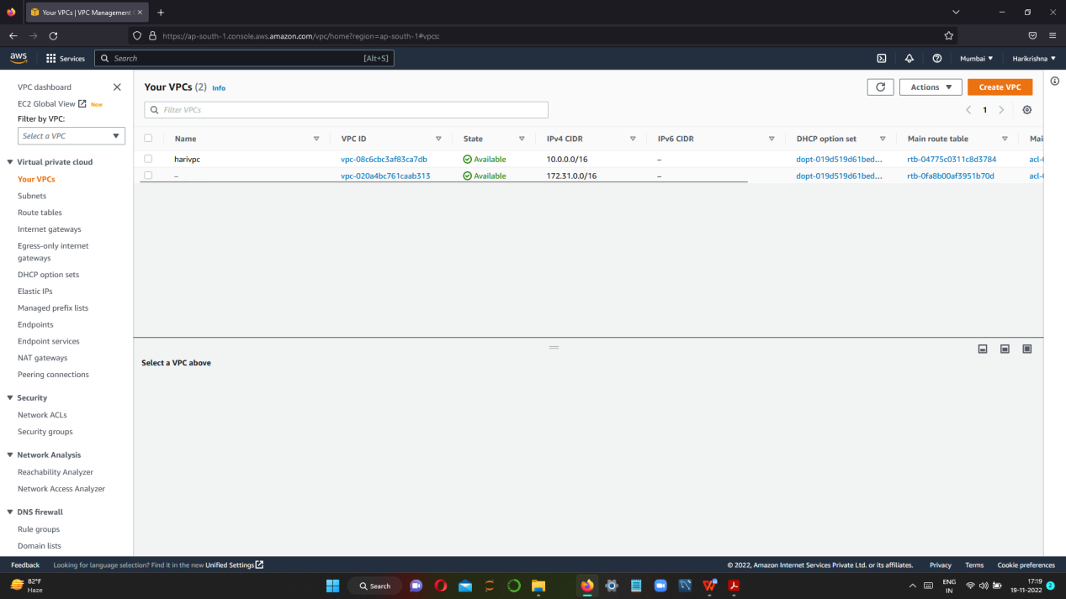

**STEP 3 CREATE PUBLIC AND PRIVATE SUBNET**

1. **PUBLIC SUBNET CREATION**

**CLICK CREATE SUBNET**

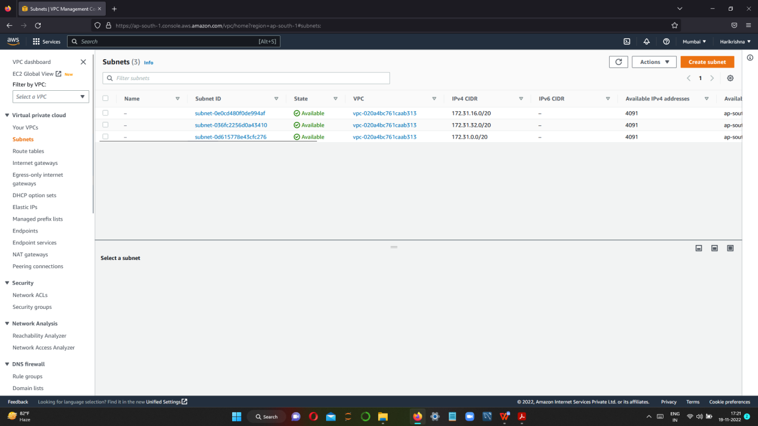

**FOR CREATING SUBNET**

**SELECT VPC NAME**

**ENTER SUBNET NAME**

**AVAILABLITY ZONE**

**IPV4 CIDR BLOCK**

**AND CLICK CREATE SUBNET**

**FINALLY PUBLIC SUBNET IS CREATED**

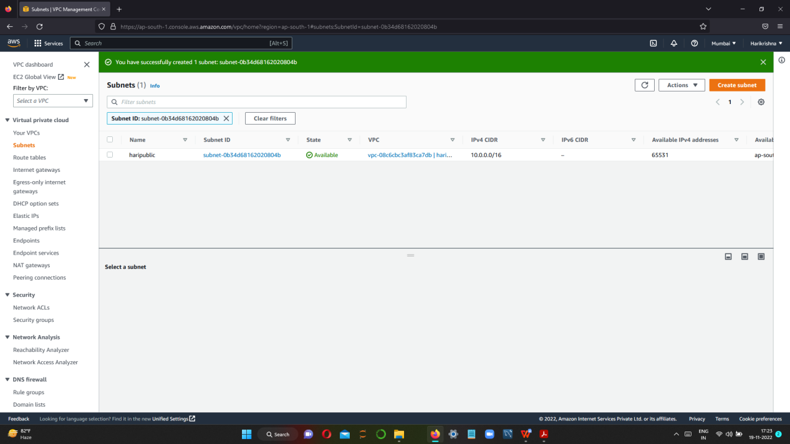

**ii) CREATING A PRIVATE SUBNET**

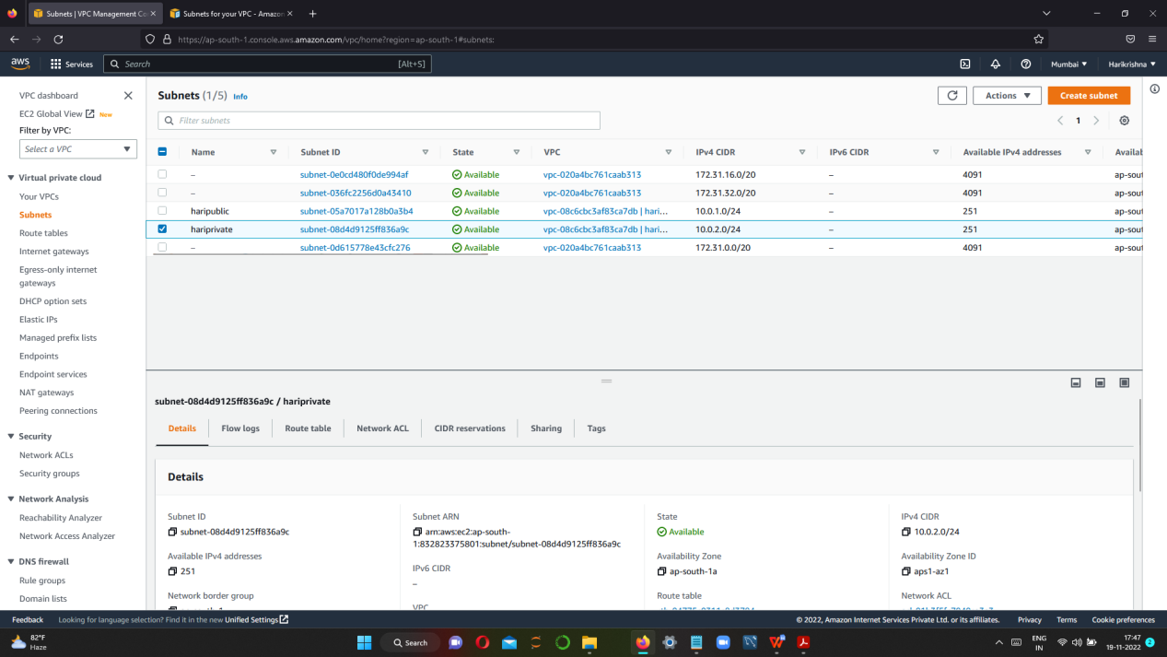

**STEP 4 CREATE INTERNET GATEWAY AND ATTACT TO VPC**

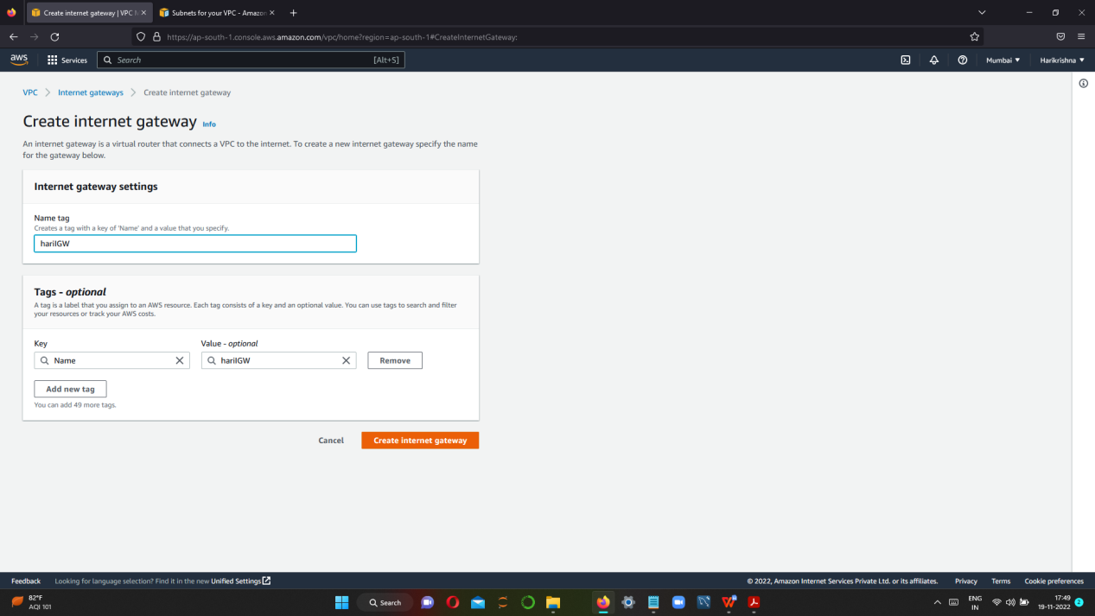

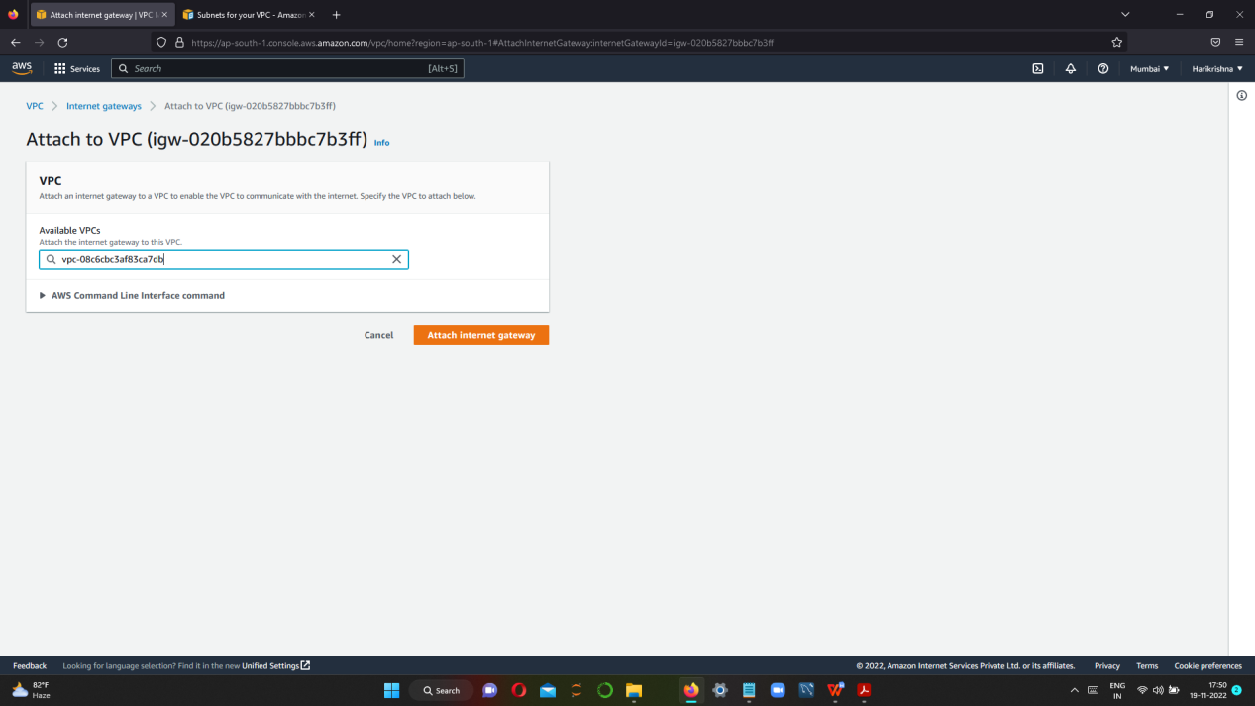

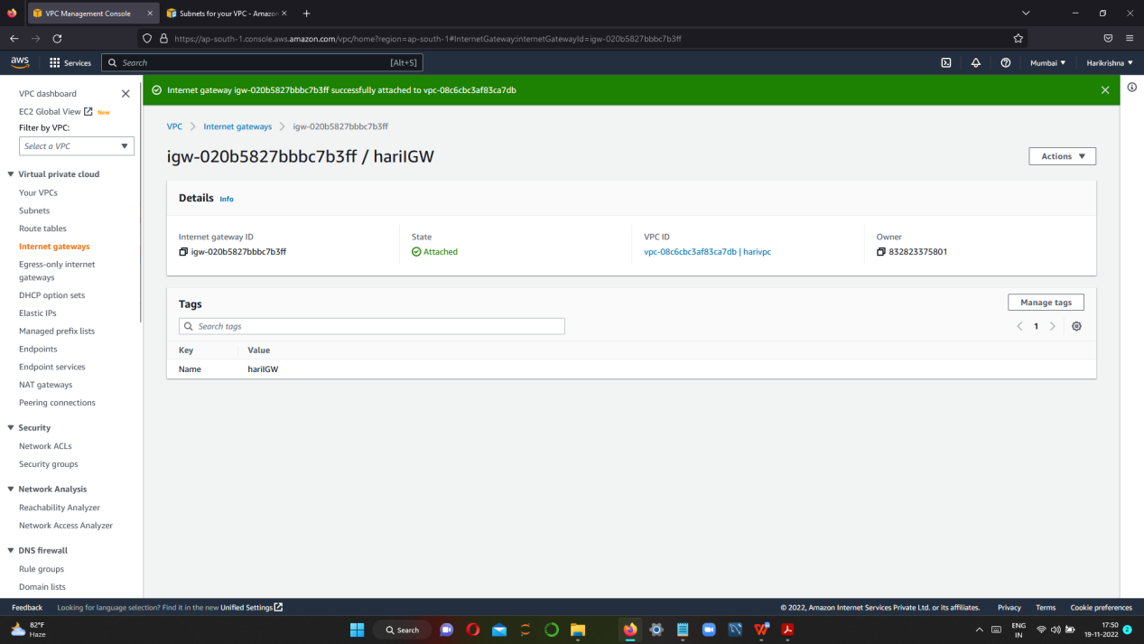

**STEP 5 CREATE PUBLIC AND PRIVATE ROUTE TABLE AND ASSOCIATE TO SUBNETS**

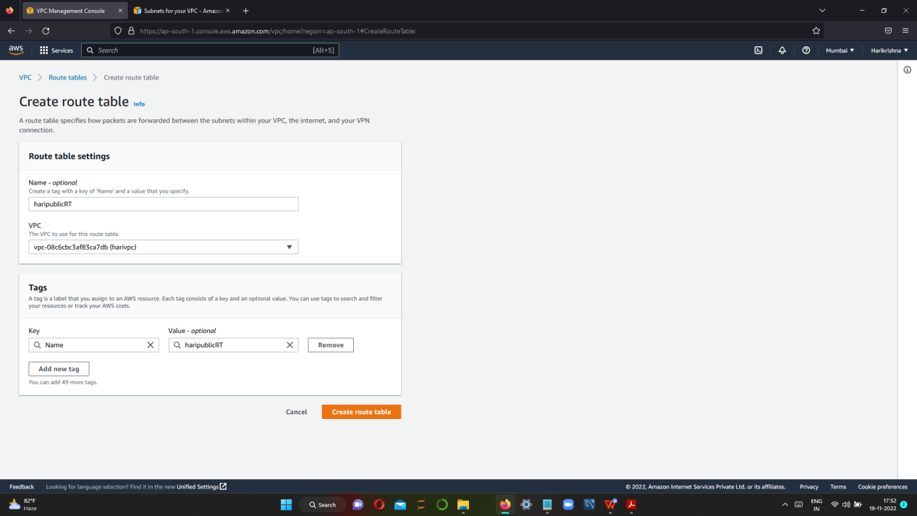

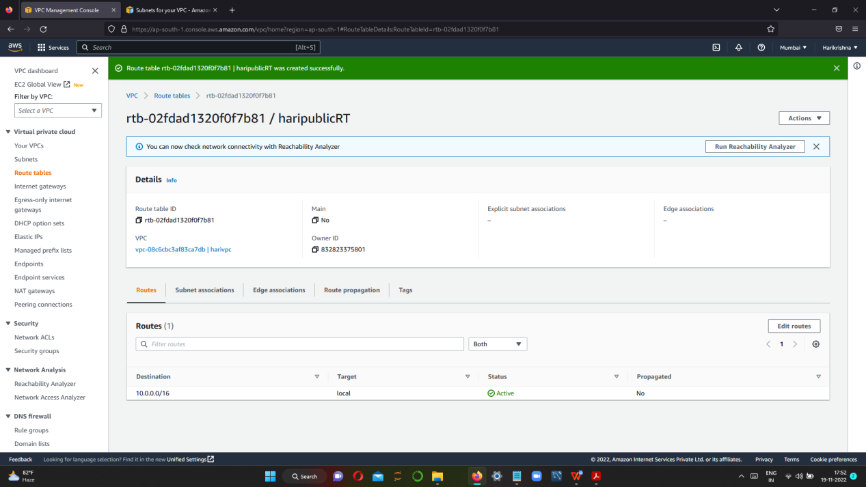

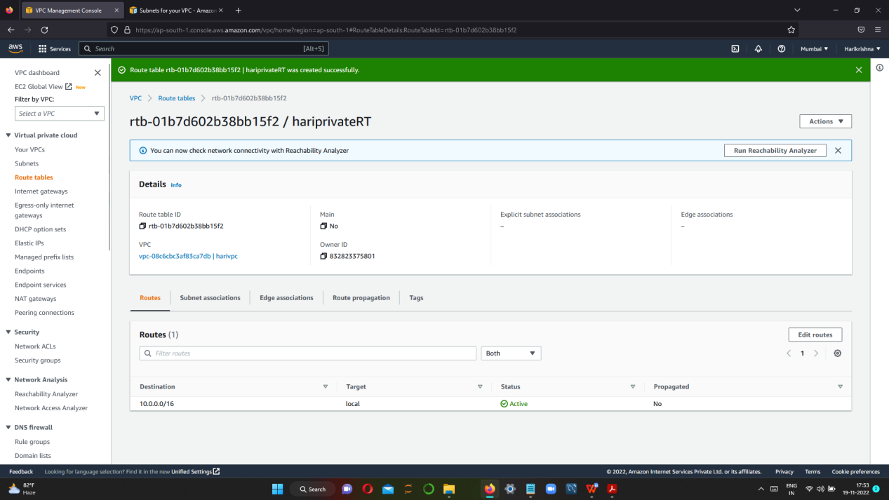

**AFTER CREATING PUBLIC AND PRIVATE ROUTE TABLE --> ATTACH TO RESPECTIVE SUBNETS**

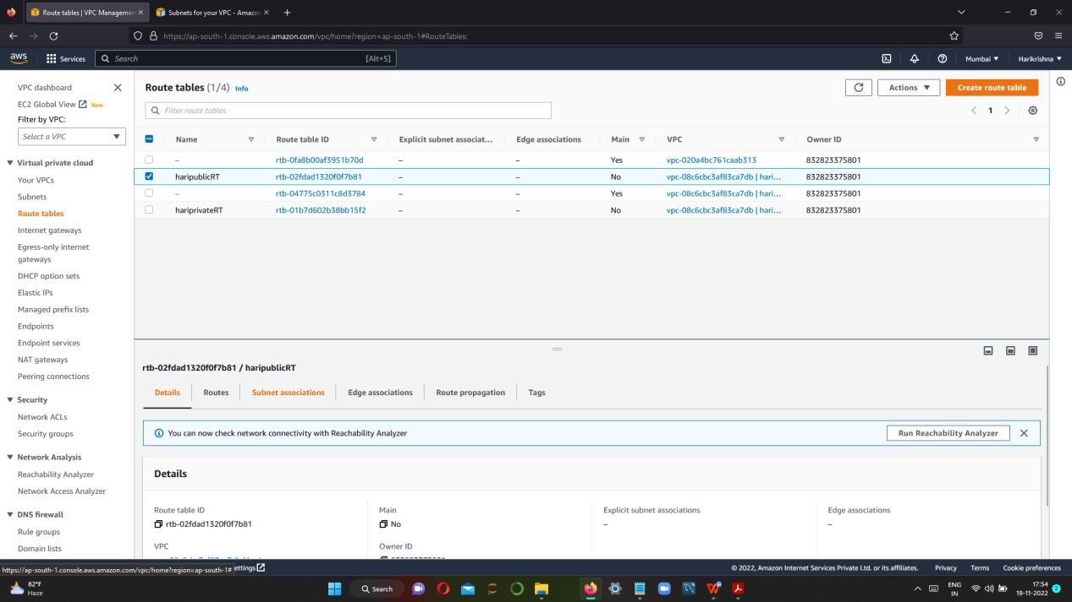

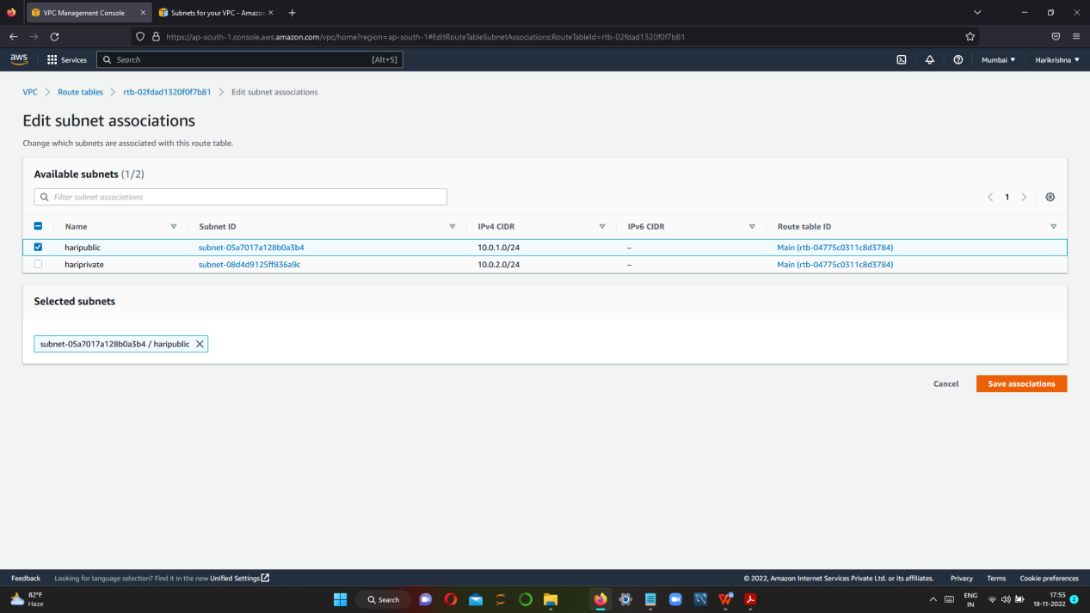

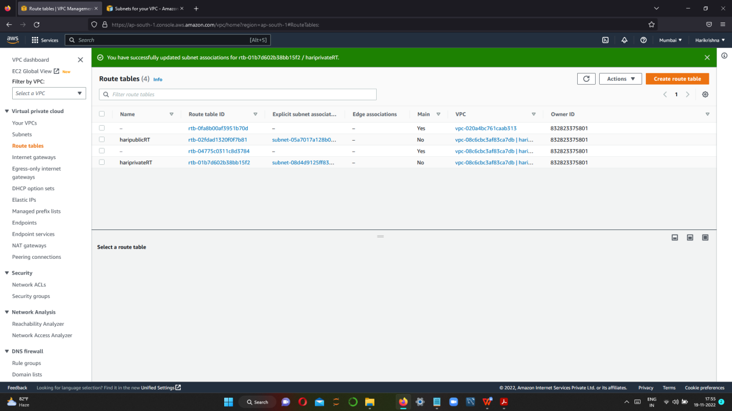

**SUCCESSFULLY ASSOCIATED BOTH SUBNET TO RESPECTIVE RT(ROUTE TABLE)**

**STEP 6 SET TO ROUTES TO RESPECTIVE SUBNETS**

1. **Route For Public Subnet**

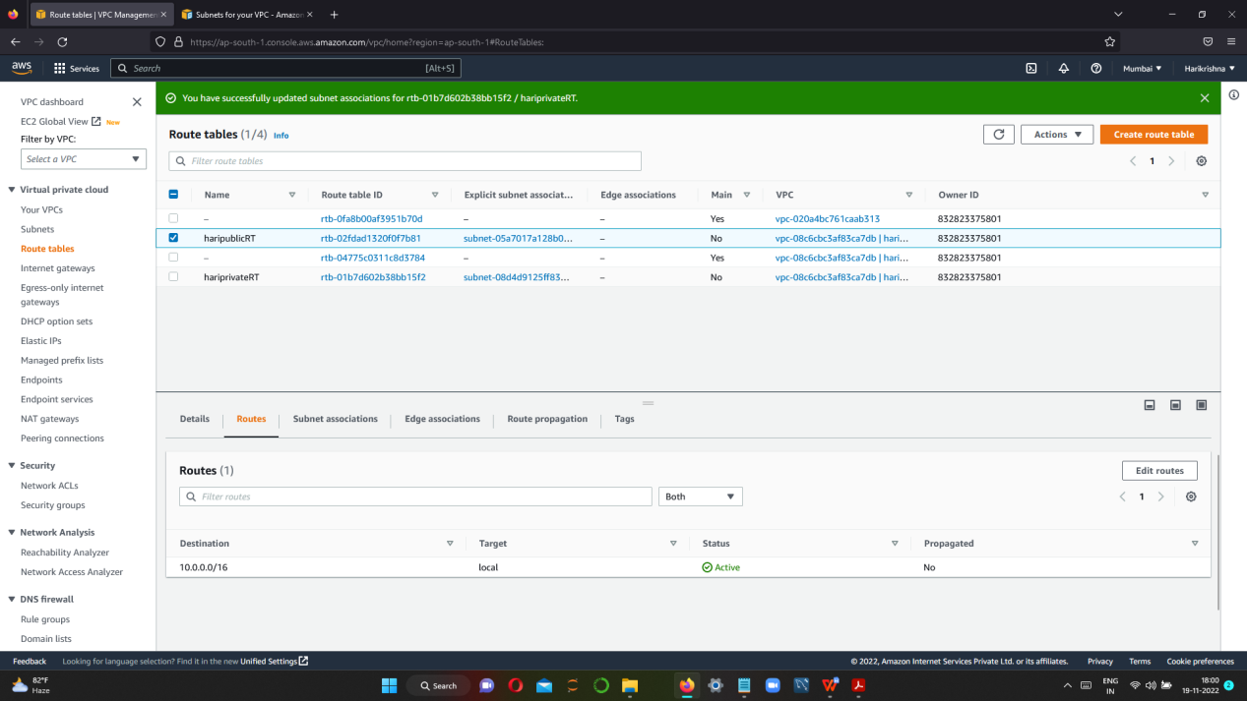

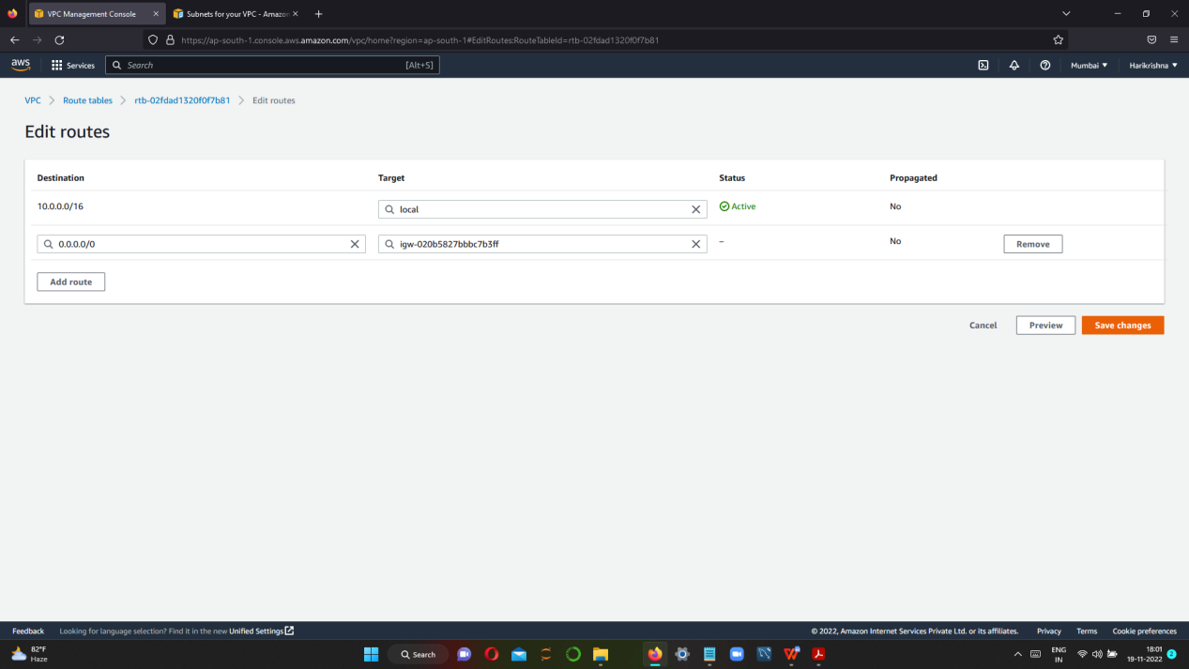

1. **Route For Private Subnet**

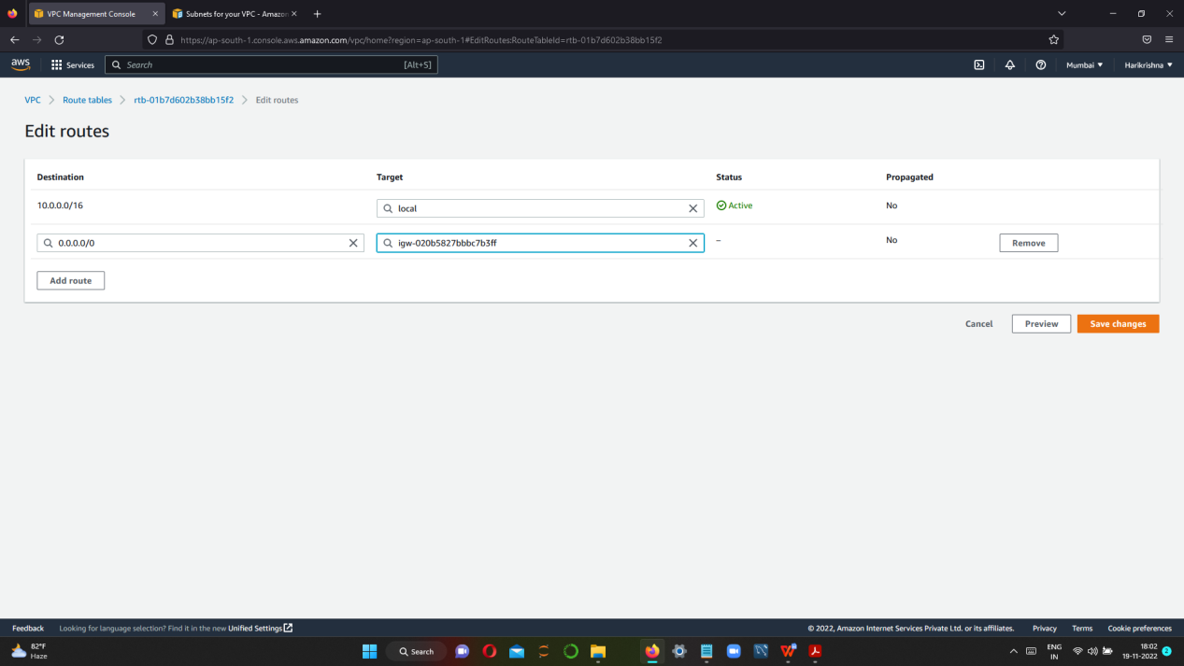

**STEP 7 SET SECURITY GROUP FOR PUBLIC AND PRIVATE**

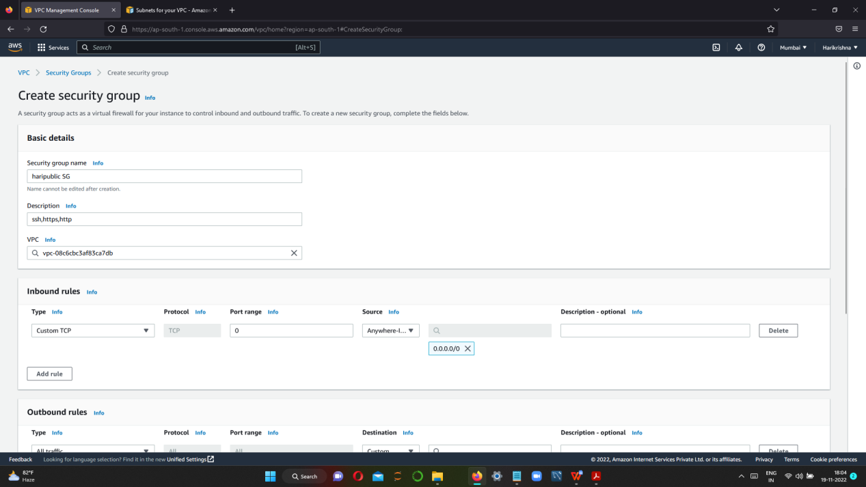

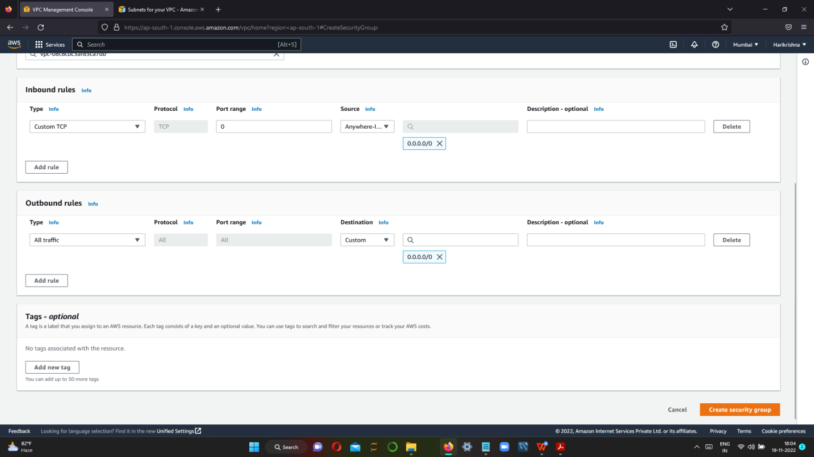

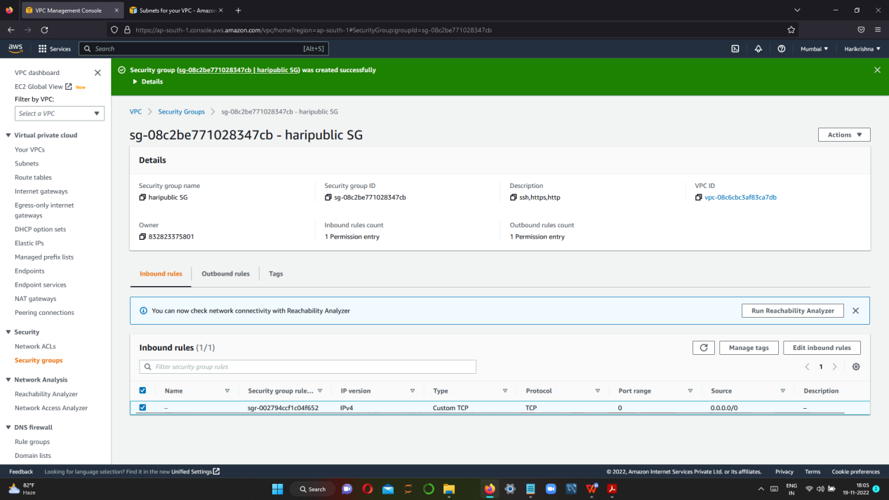

**NOW CREATE PRIVATE SG**

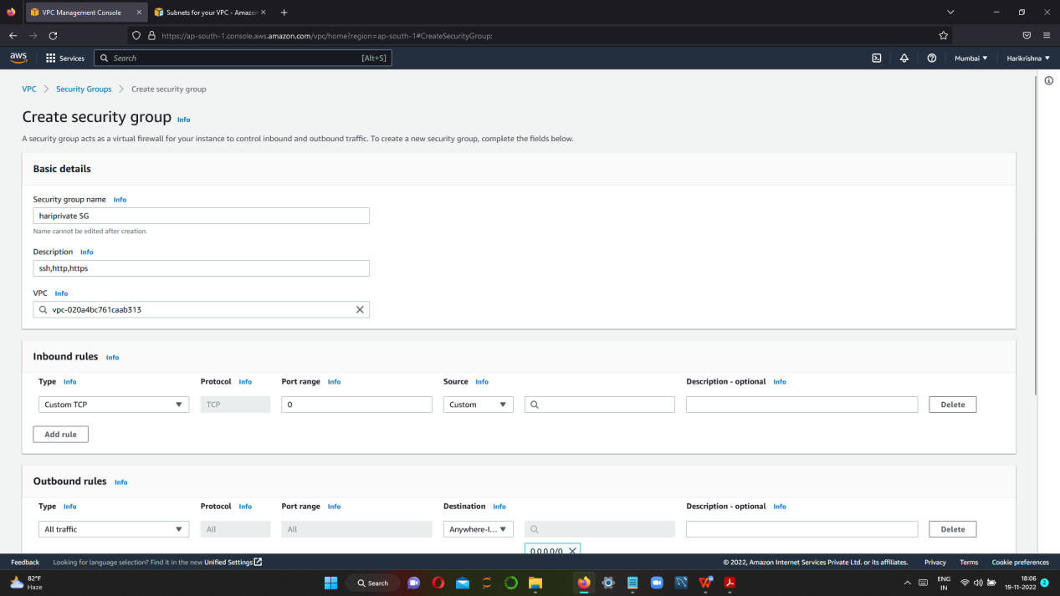

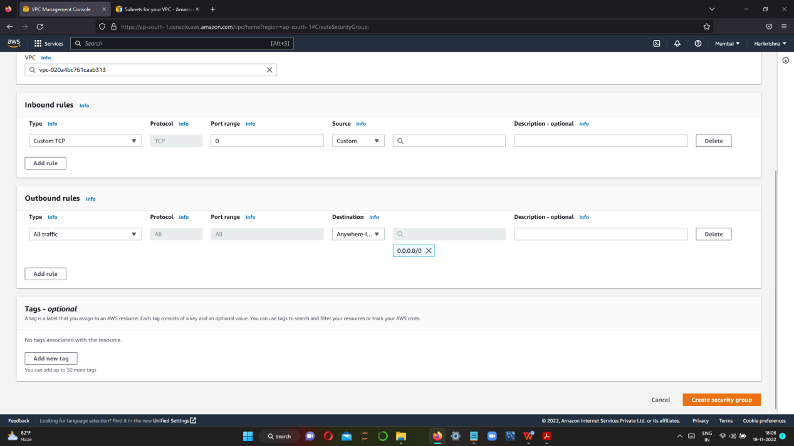

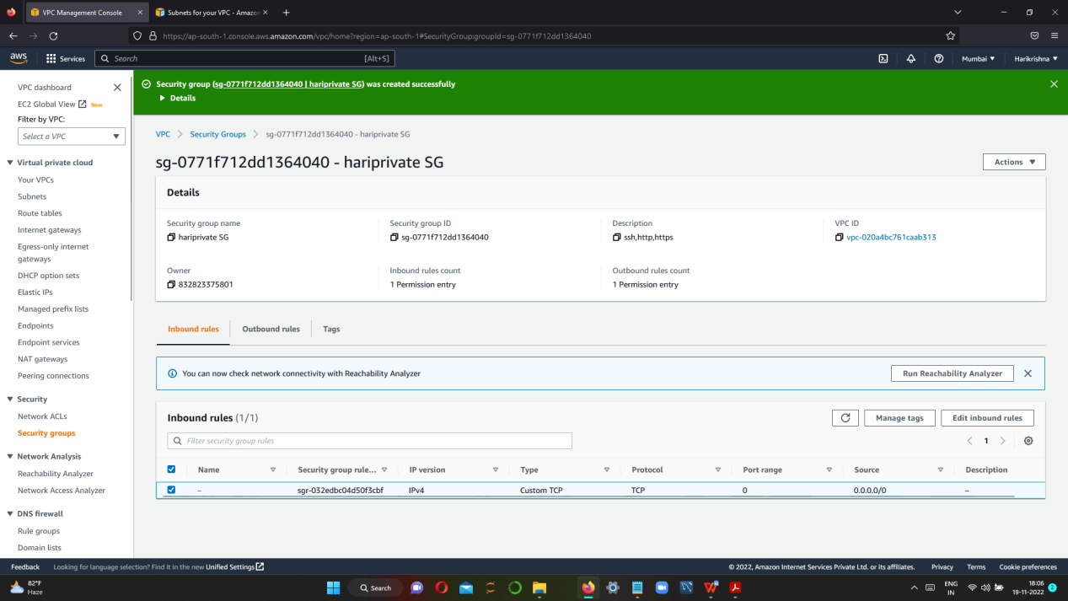

**NOW, EDIT INBOUND RULES FOR PUBLIC AND PRIVATE**

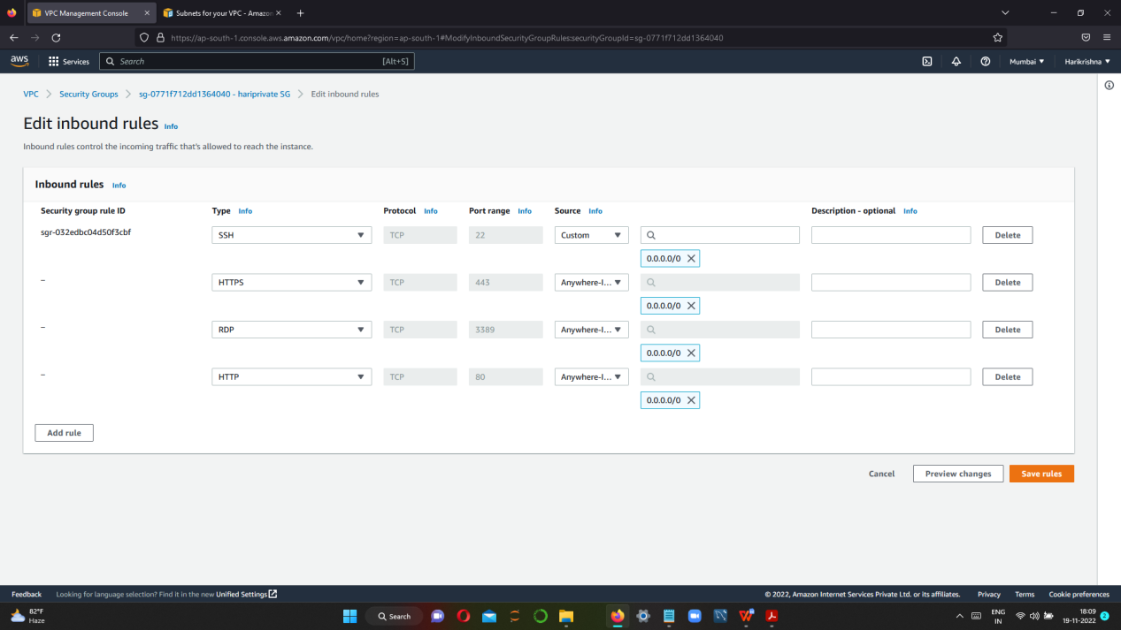

**STEP 8 CREATE PUBLIC AND PRIVATE INSTANCE IN WINDOWS**

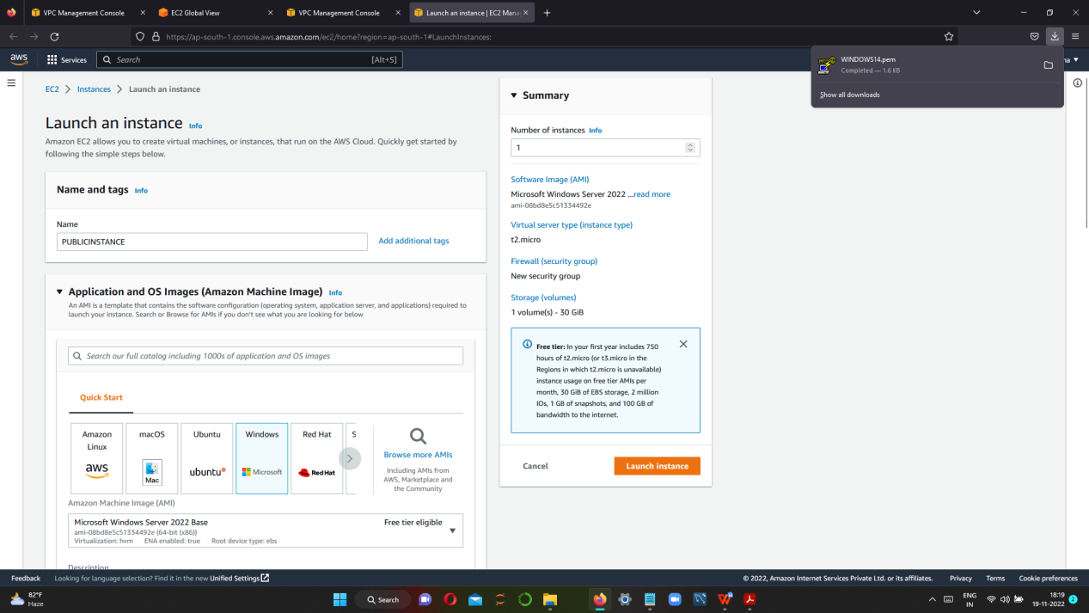

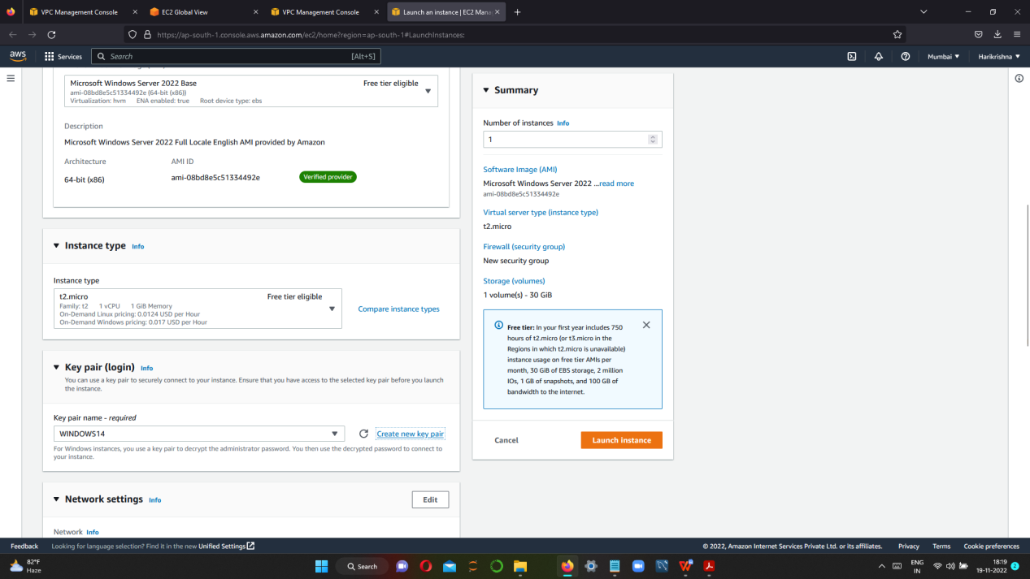

**EDIT NETWORK SETTINGS**

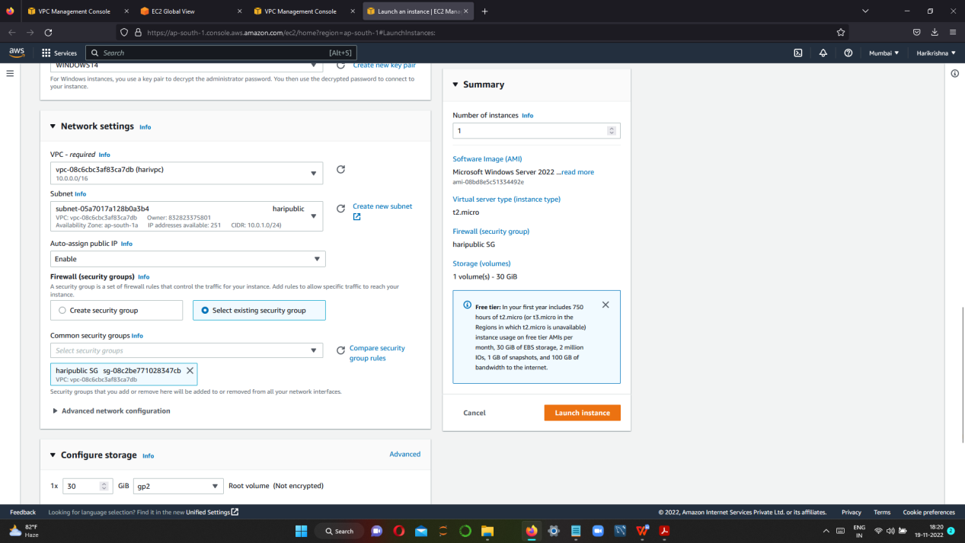

**STEP 9 CREATE PUBLIC AND PRIVATE INSTANCE**

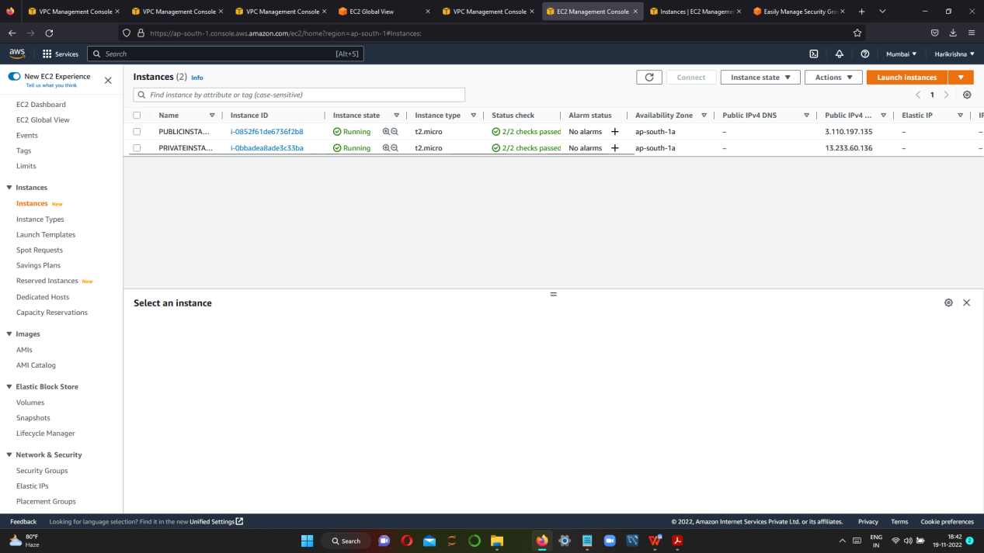

**NOW WE CAN CHECK PUBLIC INSTANCE IS GETTING INTERNET ACCESS OR NOT.**

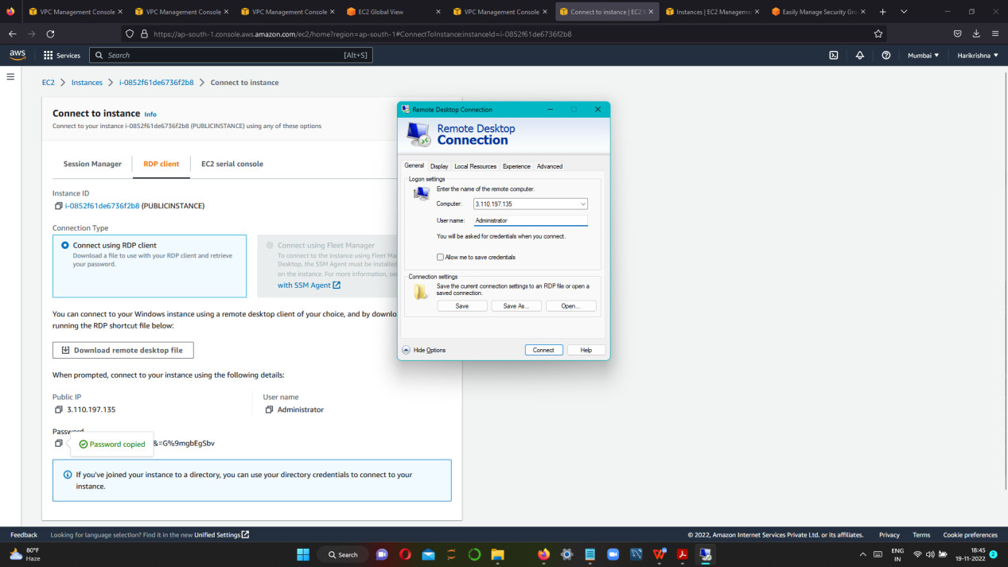

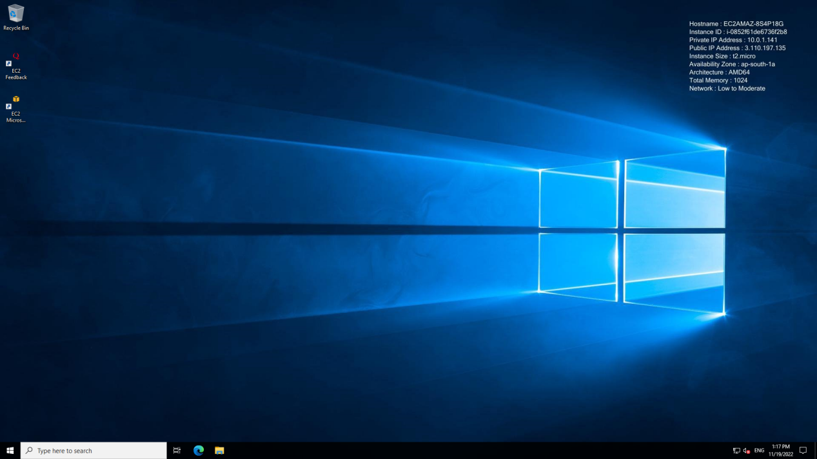

**IN PUBLIC INSTANCE WE ARE GETTING INTERNET ACCESS**

**NOTE: IN PRIVATE INSTANCE WE DON’T HAVE PUBLIC IP,IF WE CONNECT PRIVATE FROM LOCAL PC,IT WILL GET ERROR**

**SO, TRY TO CONNECT PRIVATE INSTANCE VIA PUBLIC VIRTUAL MACHINE ,FOR THAT WE HAVE TO CREATE NAT**

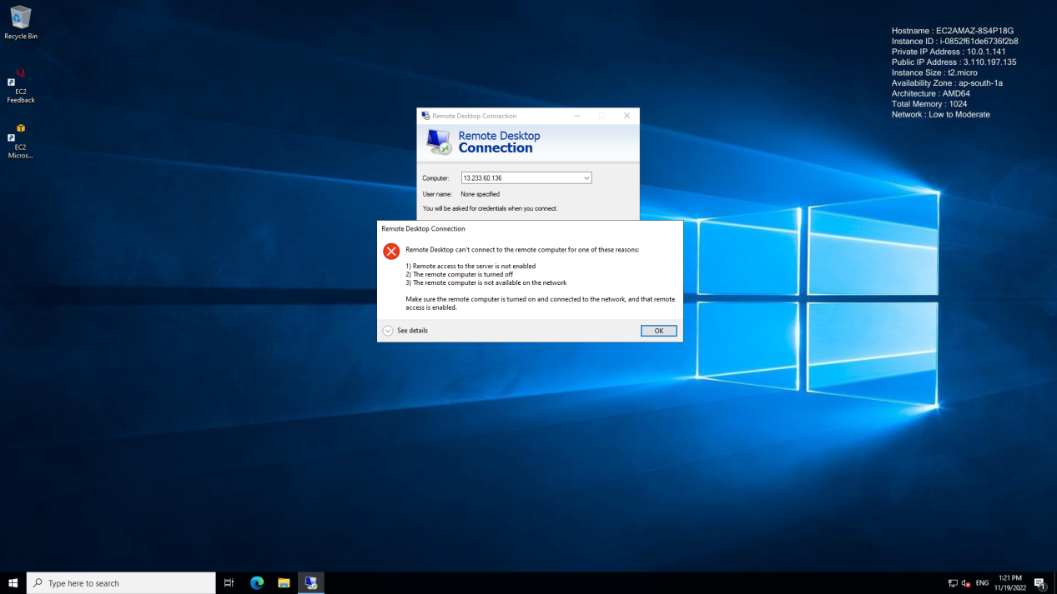

**CREATING NAT GATEWAY**

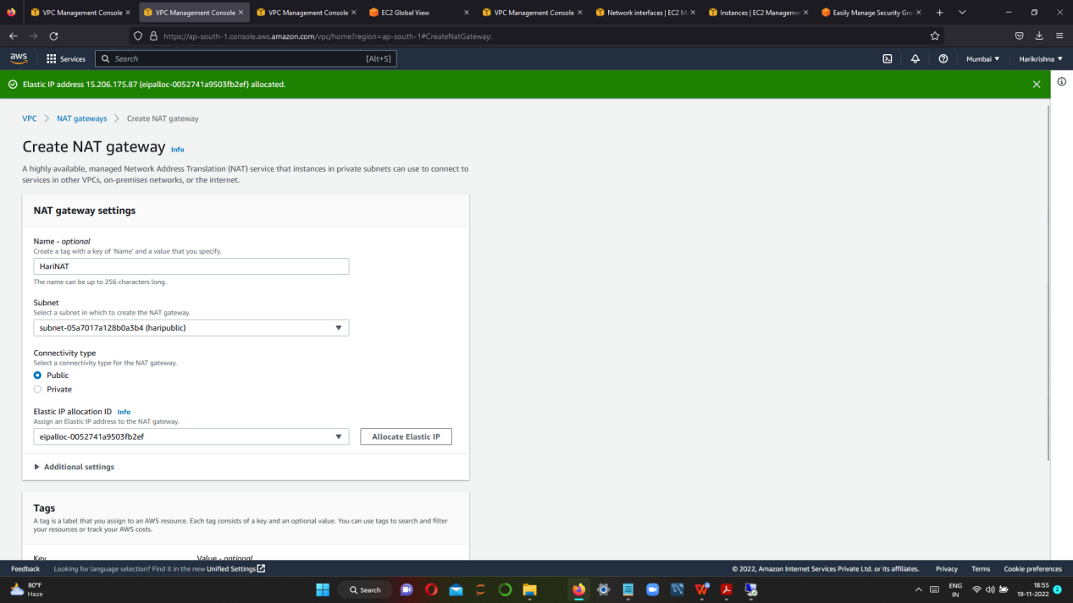

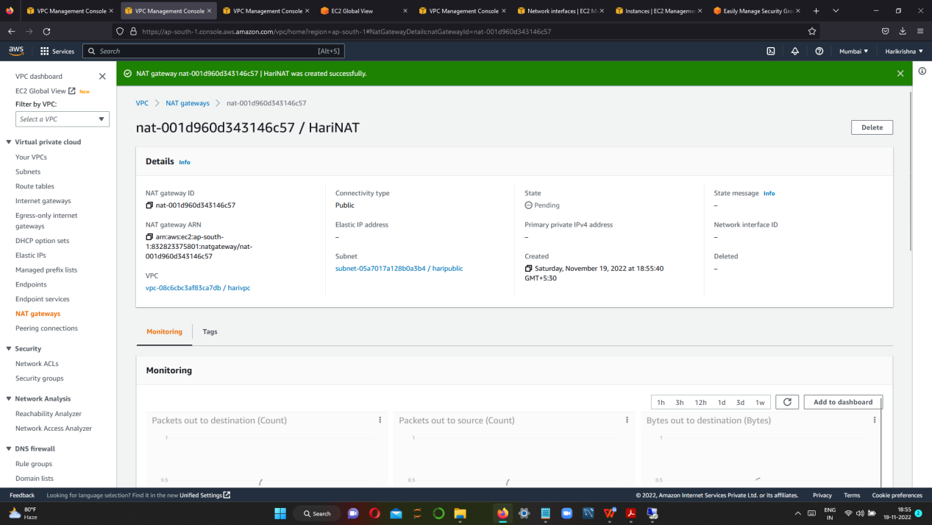

**AFTER NAT CREATION ,OPEN REMOTE DESKTOP CONNECTOR IN PUBLIC INSTANCE**

**PASTE PRIVATE IP ADDRESS & GIVE USERNAME AND PASSWORD**

**PRIVATE INSTANCE VIRTUAL WILL OPEN**

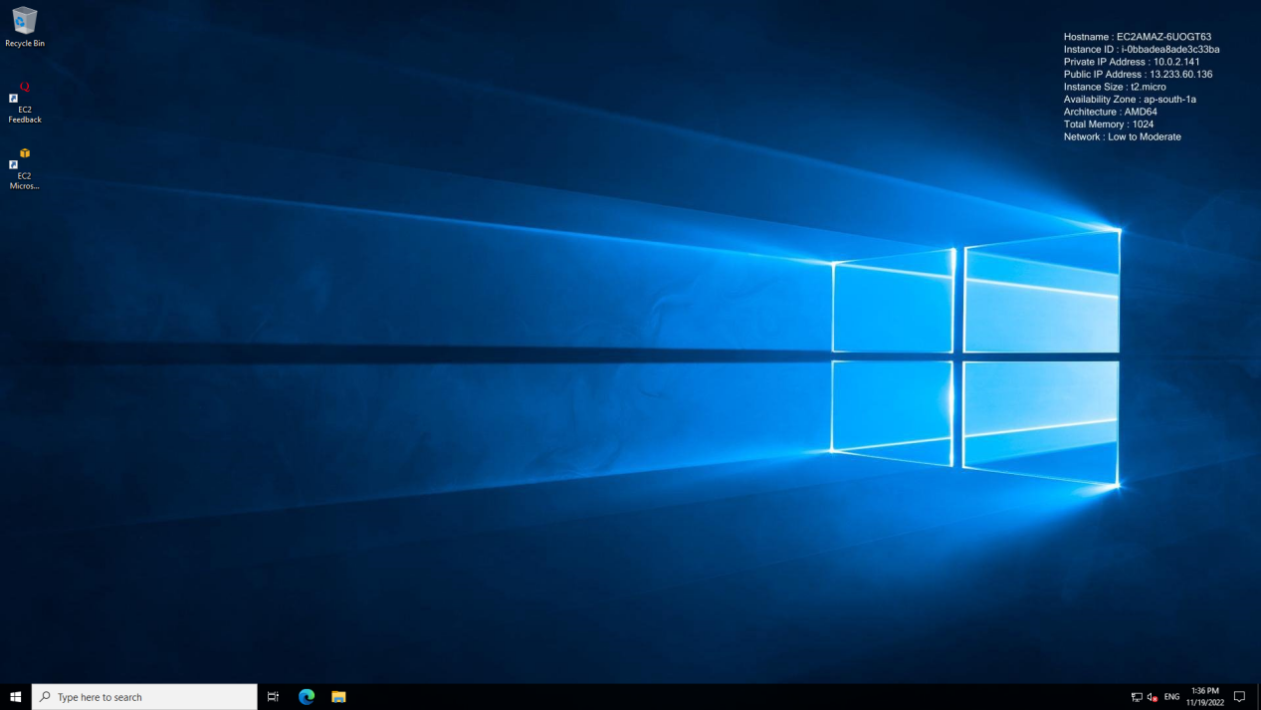

**HERE WE HAVE INTERNET ACCESS FOR PRIVATE INSTANCE ALSO**